Lab - Calculate IPv4 Subnets

# Objectives

Part 1: Determine IPv4 Address Subnetting

Part 2: Calculate IPv4 Address Subnetting

# Background / Scenario

The ability to work with IPv4 subnets and determine network and host information based on a given IP address and subnet mask is critical to understanding how IPv4 networks operate. The first part is designed to reinforce how to compute network IP address information from a given IP address and subnet mask. When given an IP address and subnet mask, you will be able to determine other information about the subnet.

* 1 PC (Windows with Internet access)
* Optional: IPv4 address calculator

# Instructions

Fill out the tables below with appropriate answers given the IPv4 address, original subnet mask, and new subnet mask.

|  |  |
| --- | --- |
| Given: | |
| **Host IP Address:** | 192.168.200.139 |
| **Original Subnet Mask** | 255.255.255.0 |
| **New Subnet Mask:** | 255.255.255.224 |

| Find: | |
| --- | --- |
| **Number of Subnet Bits** | 3 |
| **Number of Subnets Created** | 8nk |
| **Number of Host Bits per Subnet** | 5blank |
| **Number of Hosts per Subnet** | 30blank |
| **Network Address of this Subnet** | 192.168.200.128 |
| **IPv4 Address of First Host on this Subnet** | 192.168.200.129 |
| **IPv4 Address of Last Host on this Subnet** | 192.168.200.158 |
| **IPv4 Broadcast Address on this Subnet** | 192.168.200.159 |

|  |  |
| --- | --- |
| Given: | |
| **Host IP Address:** | 10.101.99.228 |
| **Original Subnet Mask** | 255.0.0.0 |
| **New Subnet Mask:** | 255.255.128.0 |

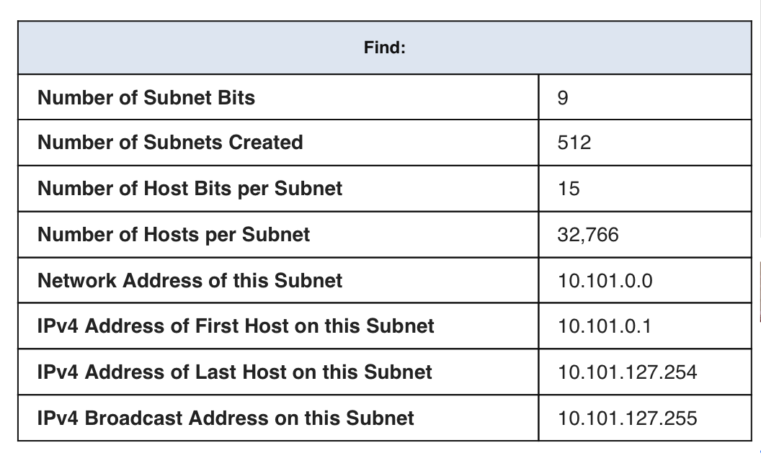

|  |  |
| --- | --- |
| Given: | |
| **Host IP Address:** | 172.22.32.12 |
| **Original Subnet Mask** | 255.255.0.0 |
| **New Subnet Mask:** | 255.255.224.0 |

**Problem 4**

|  |  |
| --- | --- |
| Given: | |
| **Host IP Address:** | 192.168.1.245 |
| **Original Subnet Mask** | 255.255.255.0 |
| **New Subnet Mask:** | 255.255.255.252 |

| Find: | |
| --- | --- |
| **Number of Subnet Bits** | blank6 |
| **Number of Subnets Created** | blank64 |
| **Number of Host Bits per Subnet** | blank2 |
| **Number of Hosts per Subnet** | Blan2 |
| **Network Address of this Subnet** | bla192.168.1.244 |
| **IPv4 Address of First Host on this Subnet** | blank bla192.168.1.245 |
| **IPv4 Address of Last Host on this Subnet** | blank bla192.168.1.246 |
| **IPv4 Broadcast Address on this Subnet** | blank bla192.168.1.247 |

## Problem 5:

|  |  |
| --- | --- |
| Given: | |
| **Host IP Address:** | 128.107.0.55 |
| **Original Subnet Mask** | 255.255.0.0 |
| **New Subnet Mask:** | 255.255.255.0 |

| Find: | |
| --- | --- |
| **Number of Subnet Bits** | Blank bla8 |
| **Number of Subnets Created** | blank bla256 |
| **Number of Host Bits per Subnet** | blank bl8 |
| **Number of Hosts per Subnet** | Blank blank bla254 |
| **Network Address of this Subnet** | blank 128.107.0.0 |
| **IPv4 Address of First Host on this Subnet** | blank 128.107.0.1 |
| **IPv4 Address of Last Host on this Subnet** | blank 128.107.0.254 |
| **IPv4 Broadcast Address on this Subnet** | blank 128.107.0.255 |

## Problem 6:

|  |  |
| --- | --- |
| Given: | |
| **Host IP Address:** | 192.135.250.180 |
| **Original Subnet Mask** | 255.255.255.0 |
| **New Subnet Mask:** | 255.255.255.248 |

| Find: | |
| --- | --- |
| **Number of Subnet Bits** | 5 |
| **Number of Subnets Created** | 32 |
| **Number of Host Bits per Subnet** | blank bla3blank |
| **Number of Hosts per Subnet** | blank bla6 |
| **Network Address of this Subnet** | blank 192.135.250.176 |
| **IPv4 Address of First Host on this Subnet** | blank 192.135.250.177 |
| **IPv4 Address of Last Host on this Subnet** | blank 192.135.250.182 |
| **IPv4 Broadcast Address on this Subnet** | blank 192.135.250.183 |

# Reflection Question

Why is the subnet mask so important when analyzing an IPv4 address?

The subnet mask determines everything about the address: the network, number of host bits, number of hosts and the broadcast address. Merely looking at an IPv4 address tells you nothing. You need the subnet mask to fill in all the important pieces of information.